RESOLUTION NO.__________

RE: CERTIFICATE OF APPROPRIATENESS UNDER THE
PROVISIONS OF THE ACT OF THE PENNSYLVANIA
LEGISLATURE 1961, JUNE 13, P.L. 282 (53
SECTION 8004) AND BETHLEHEM ORDINANCE NO.
3952 AS AMENDED.

WHEREAS, it is proposed to install new signs at 308 E Third Street.

NOW, THEREFORE, BE IT RESOLVED by the Council of the City of Bethlehem that a Certificate of Appropriateness is hereby granted for the work.

Sponsored by: (s)

(s)

ADOPTED BY COUNCIL THIS DAY OF

(s)
President of Council

ATTEST:

(s)
City Clerk

HISTORIC CONSERVATION COMMISSION

CASE # 571– It is proposed to install new signs at 308 E Third Street
OWNER/APPLICANT: Kathleen Elek / Beyond Juice LLC

The Commission upon motion by Mr. Evans seconded by Mr. Roeder adopted the proposal that City Council issue a Certificate of Appropriateness for the proposed work described herein:
- The proposal to install new signs at 308 E Third Street was represented by Eric Collado.
- A 2’ round blade sign will hang from a metal bracket to the left of the front window. The design and materials of the sign will be as submitted to the HCC.
- An individually lettered sign will be installed about the storefront windows in the entablature. The letters will be 6”+/- cut out PVC letters. There will be at least a 1” space between the top of the letters and the brackets and the bottom of the letters and the entablature molding. The letters will be red with a yellow outline, and it recommended that they be centered on the building as shown in the rendering submitted.
- Vinyl window graphics will be installed on the front window. The graphics will be 20% smaller the graphics shown in the rendering submitted to the HCC. It will be placed slightly above center in the window.
- The door may have a small graphic sign matching the display window sign and a list the hours. The HCC recommended deleting the graphic sign on the door.
- All signs will read “Beyond Juice” in red with a fruit graphic.
- The signs will not be illuminated.
- The proposed motion was unanimously approved.

CU: cu
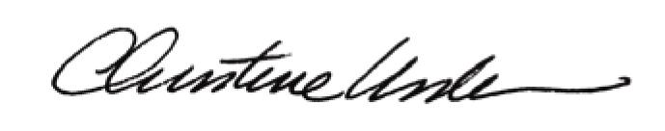

By:

Date of Meeting: November 16, 2015 Title: Historic Officer

